**Real Estate Business Requirement**

**Table of Content**

1. SysConfig
   1. Land Type
   2. Activity Type
   3. Activity
   4. Cost Type
   5. Income Type
   6. Area Type
   7. Parameters
   8. Parameter Value
   9. Reminder Parameters
2. Projects
   1. New Project
   2. Budget
   3. Budget Transfer
   4. Other Income
3. Project Development
   1. Block Out
   2. Budgeted Sales
   3. Development Bills
   4. Block Pricing
   5. Cost Allocation
   6. Common Area
   7. Block Valuation
4. Inquiry
   1. Make Inquiry
   2. Inquiry Values
   3. Match Inquiry
5. Reservation
   1. Customer Creation
   2. Make Reservation
   3. Cancel Reservation
   4. Transfer Reservation
6. Maintenance
   1. Payment Details
   2. Confirm Application
   3. Direct Debit
   4. Termination
   5. Reminder Printing
   6. Reminder Re-Printing
7. Information
   1. Project Map
   2. Site Map
   3. Budgeted Cost
   4. Project Inquiry
   5. Tax Calculation
   6. Block Profit
   7. Block Cost/Profit
   8. Age Analysis
   9. Block Cost Details
   10. Info Console
8. Reports
   1. Current Project
   2. Evaluation Report
   3. Price List
   4. Land Stock
   5. Cost/Profit Variance
   6. Project Profitability
   7. Age Analysis
   8. Status Report
   9. Client Statement
   10. Profit Realized
   11. Project Profit Analysis
   12. Project Block Status
9. Administration

Project 🡪New Project

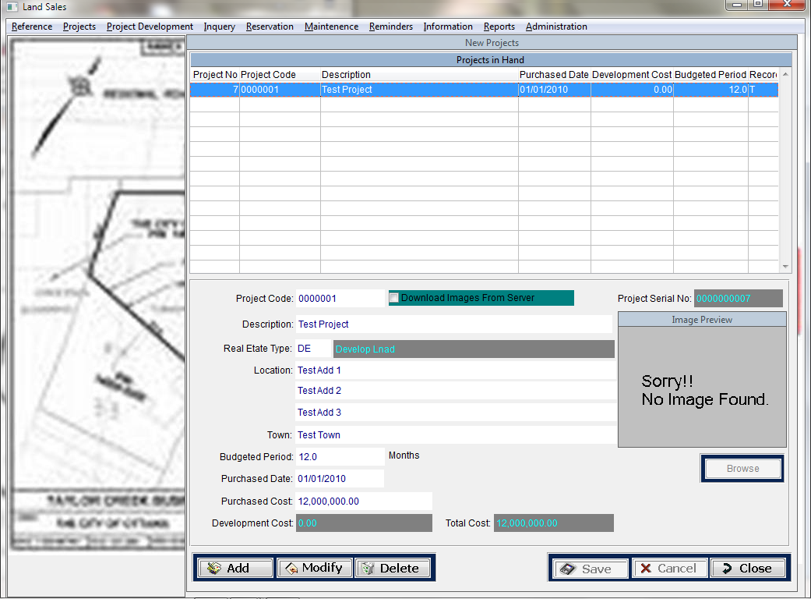

Creating New Project once the Evaluation done for the land that the company looking for

**Field List**

Project Code

Description

RealEstate Type

Location 🡪 Address Line 1, Address Line 2, Address Line 3, Town

Budgeted Period

Purchase Cost

Purchase Date

Land Image

Extent

Cost of Capital Rate

Discount

Perch Price

Owner’s Name

Introducer’s Name

Project 🡪 Budget

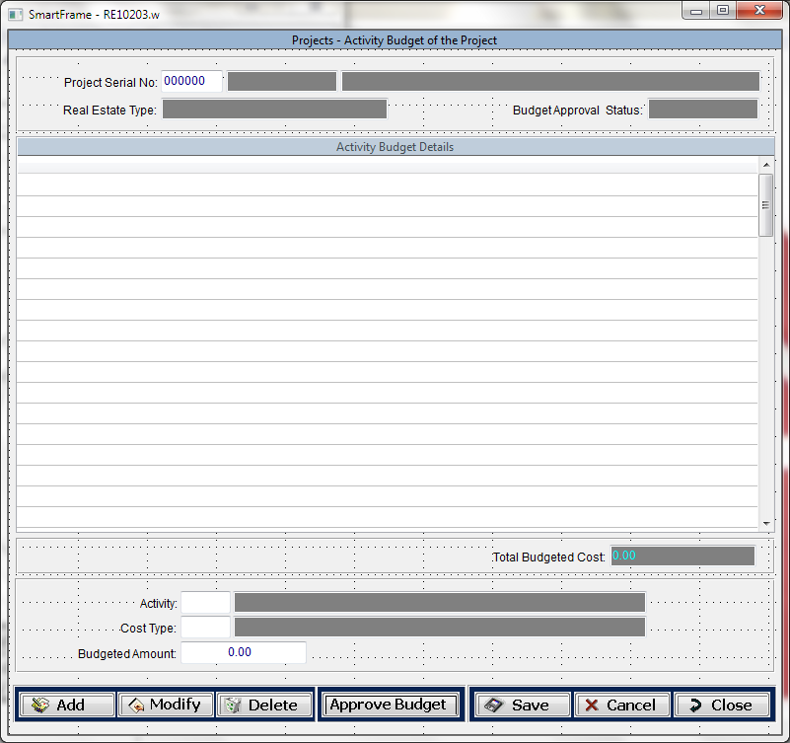

Budget for the Project, this will defines the budgeted cost for each item that the company has to work on to develop the land that they have purchased.

Also this budget has to be approved once the all Cost item are entered, this budget approval has be go through a Levels of Approvals as follows

**Total Budget >1M <=2M 1 Set Of officers**

**Total Budget >2M <=3M 2 Set Of officers etc**

Once the Budget approved we need to pass the GL Entries to the General Ledger

**Field List**

Activity Type

Cost Type

Budgeted Amount

Once the budget approved users can’t make changes to the Budget but if user needs to do a budget increment then they has to go through a budget Revision

Project 🡪Budget Transfer

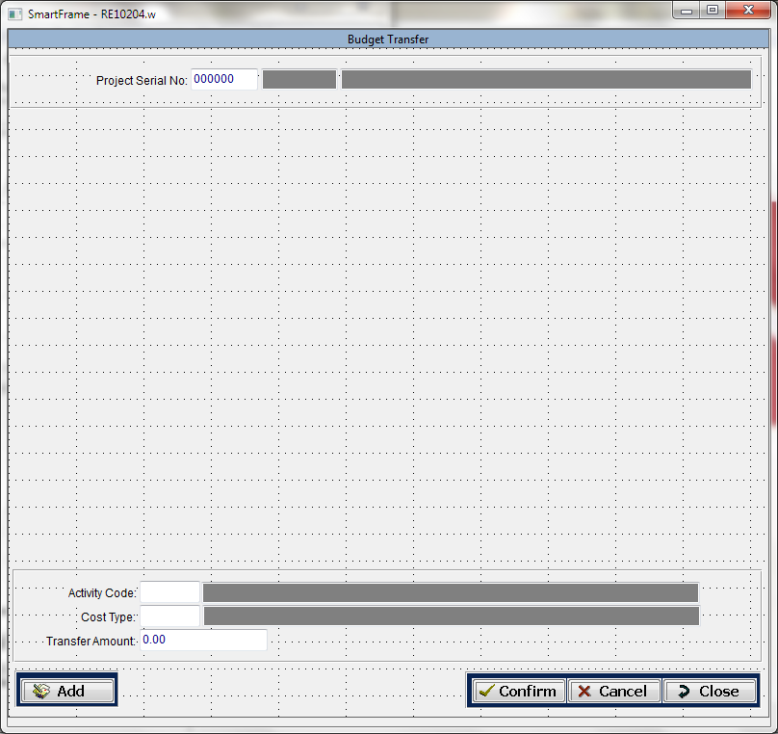

This screen allows user to transfer the budgeted amount among the Items but not among the Budget or the Project

**Field List**

Activity Type

Cost Type

Budgeted Amount

Project🡪Other Income

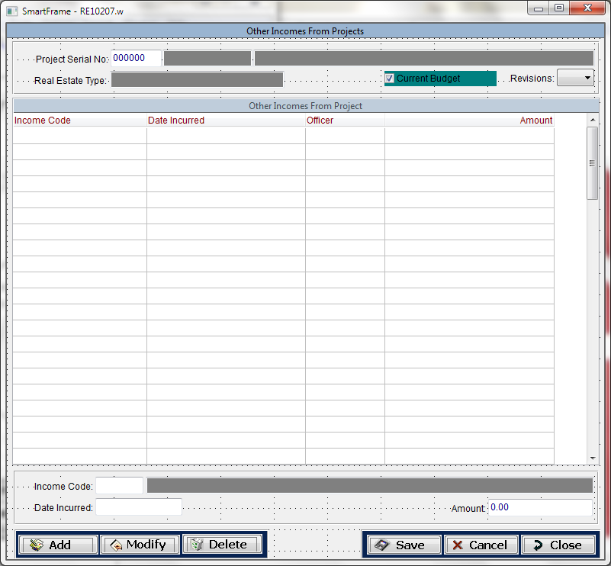

This screen allows users to enter other income that have incurred from the land this can be Jack Tree, Teak Tree, Building

**Field List**

Income Type

Date Incurred

Amount

Project Development🡪 Block Out

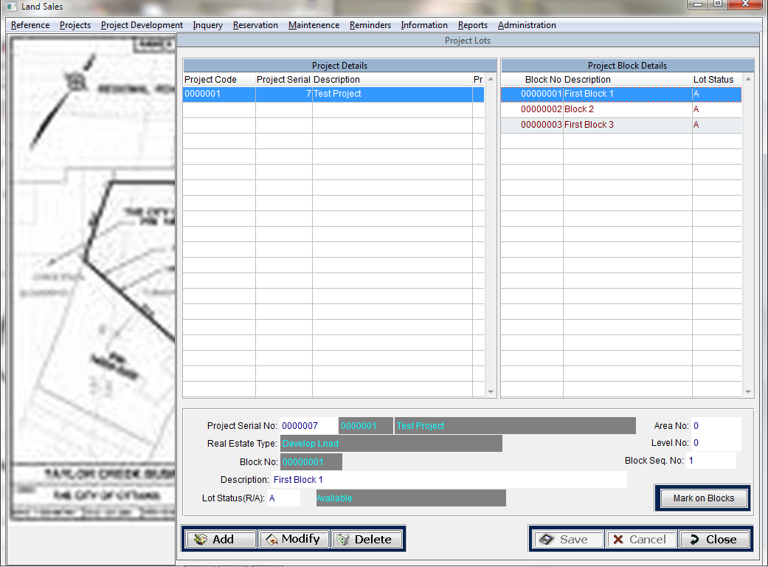

This screen Allows users to Bock out the Land that they have purchased, when creating the Block numbers 13 number should be eliminated, also this enables the users to mark the Block on the Image that they have imported to the system

**Field list**

Block Description

Block Extent

Perch Price

Also User can Mark the Block on the Block out Image

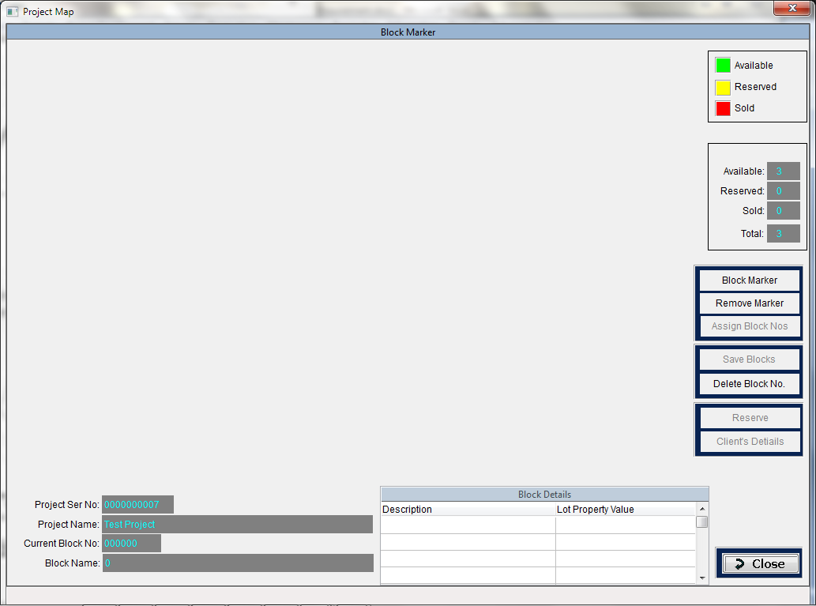

Project Development🡪 Budgeted Sales

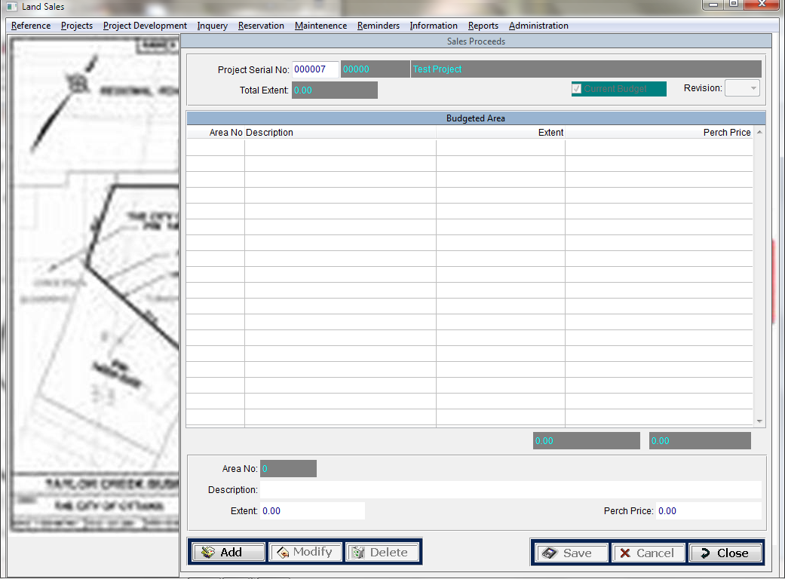

Before starting the Land Sales after Land Development users can enter the budgeted Sales actually this is the target Sales for the Project

**Field List**

Project Serial

Revision

Description

Area No

Extent

Perch Price

Project Development🡪 Development Bills

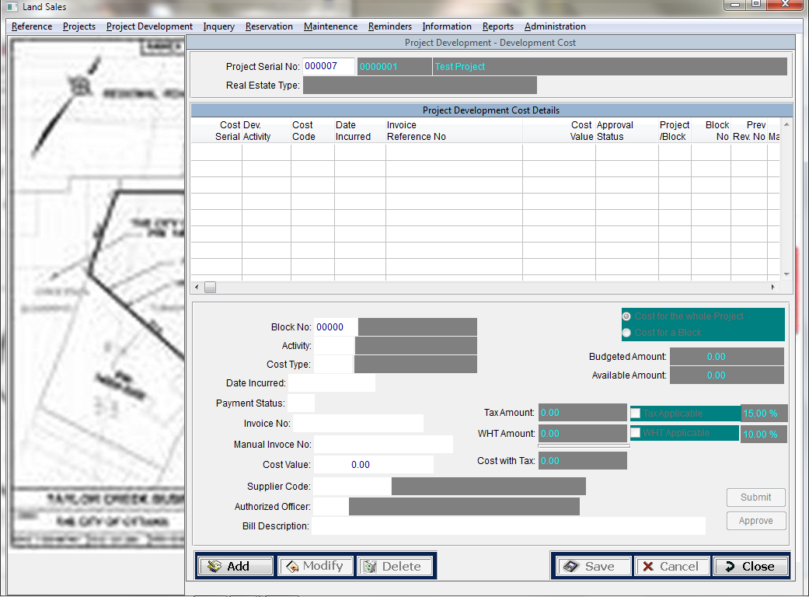

This screen Allow users to enter development Bills for the Project also each development bill need a Authorized persons approval.

Once the Authorized Person Approves the bills system automatically passes the Ledger Entries for the particular Bill and it’ll be available in Payment Voucher to pay the Cheque for Supplier or the Vender

Once the Bill enters in to the System the bill amount should be deducted from the budgeted cost from the cost type

**Field List**

Project Serial

Block No

Activity

Cost Type

Date Incurred

Payment Status

Invoice No

Manual Invoice No

Cost Value

Supply Code

Authorized Office

Bill Description

TAX Amount

WHT Amount

Project Development 🡪Cost Alocation

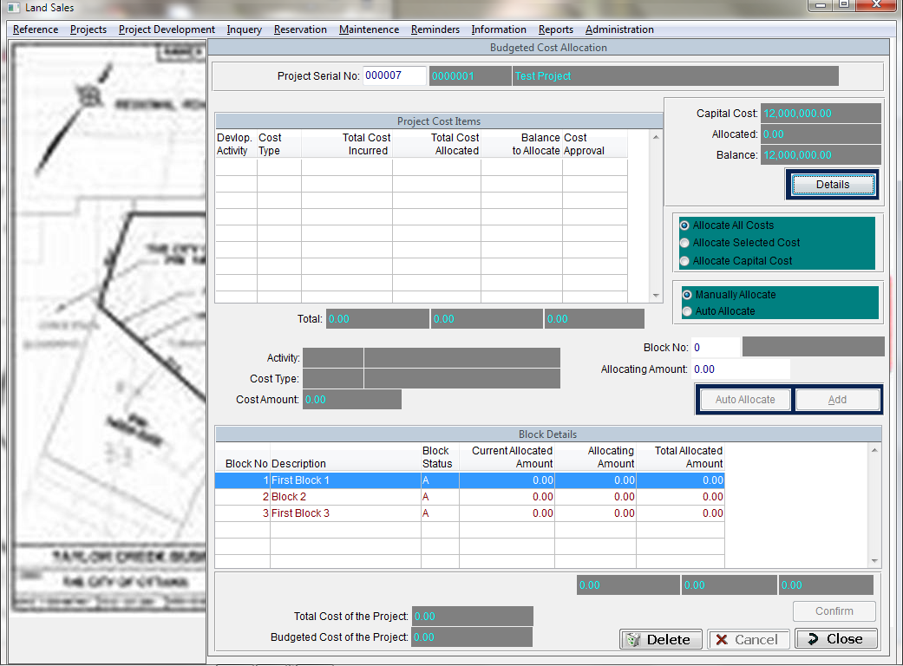

This Screen allows user to allocate all cost of the Project to the each Block, there are two types of cost, Development Cost and Capital Cost

Allocation Method

Proportionately for Selling Price

**Block Selling Price /Total Selling Price * 100**

Proportionately for Extent

**Block Extent/Total Extent * 100**

Project Development🡪Common Area

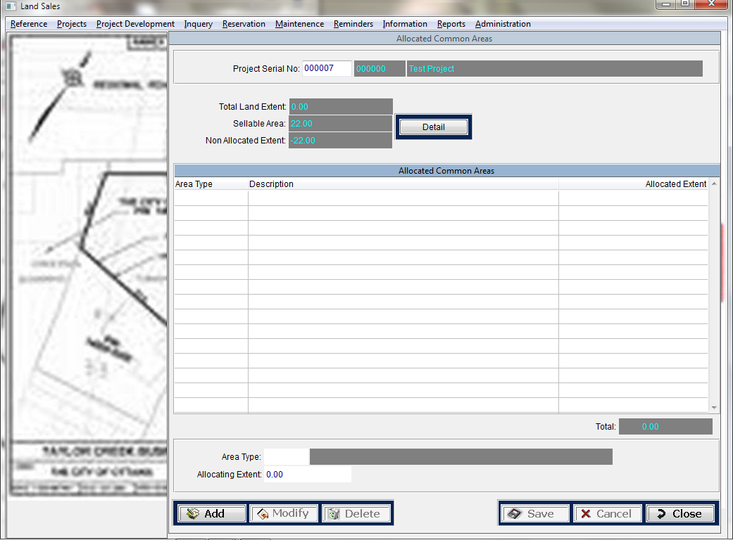

This screen allow users to define Common areas for the Project

**Field List**

Area Type

Allocating Extent

Project Development🡪 Block Valuation

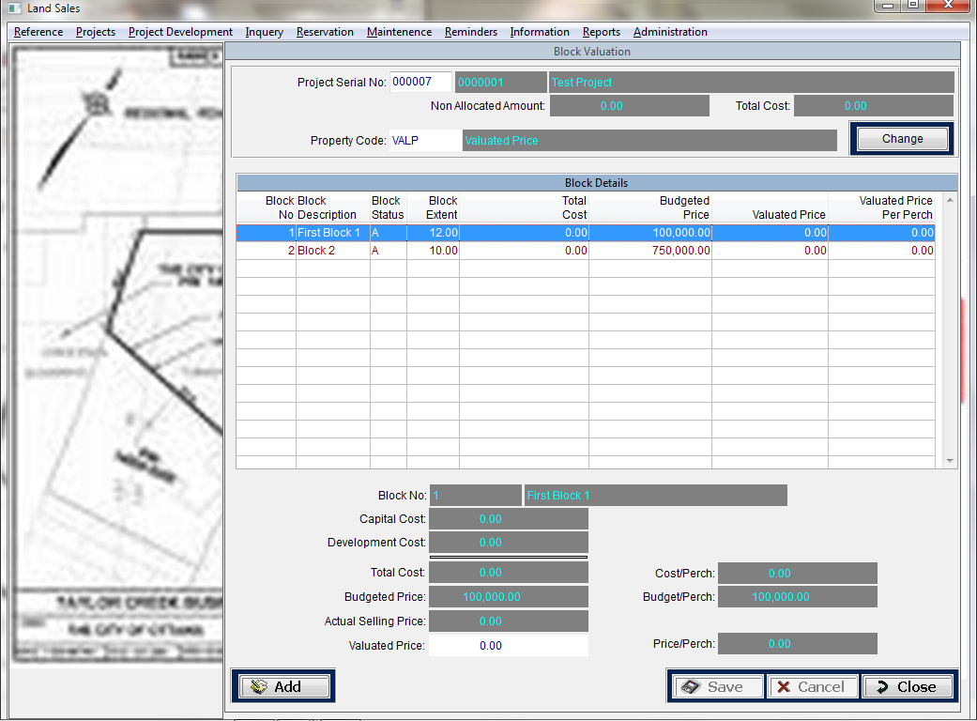

This Screen allows user to enter Block Valuation for the particular value for the block

**Field List**

Project Serial

Block Serial

Value

Reservation 🡪 Make Reservation

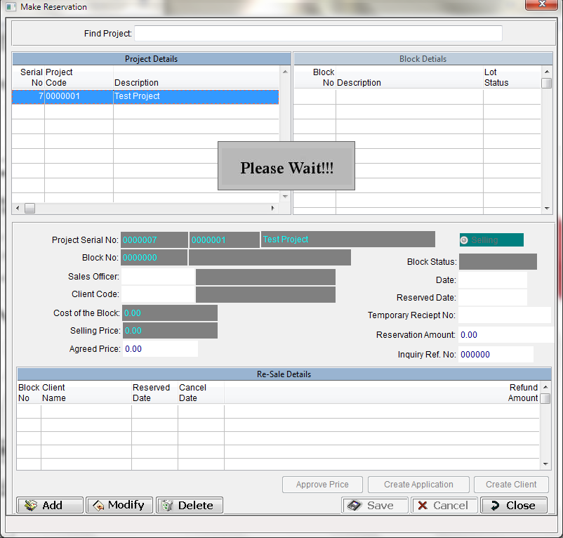

This screen allow users to enters the customers reservation for the block, user can enter the agreed value but if it is less than the budgeted selling price there should be an authorization

**Field List**

Sales Officer

Customer Code

Date

Reserve Date

Temporary Receipt Date

Reservation Date

Agreed Price

Reservation🡪 Cancel Reservation

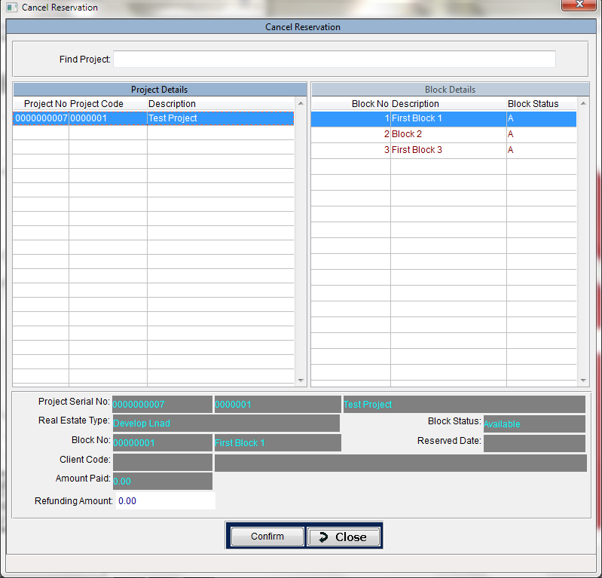

This screen allow users to enter reservation cancellation to the system

**Filed List**

Refund Amount

Reservation🡪 Cancel Reservation

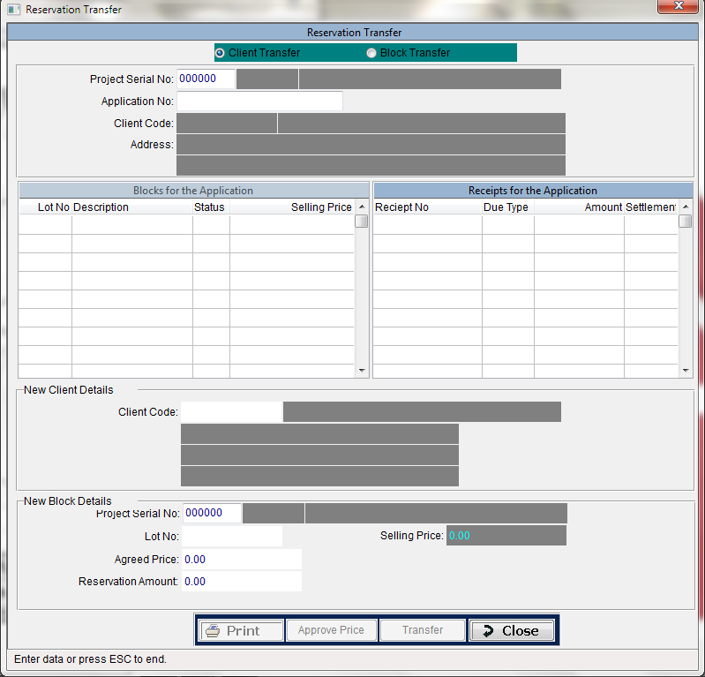

This screen allows users to transfer the reservation made by the customer for a block.

Reservation transfer could be happen two ways.

* Customer transfer
* Block transfer

**Customer Transfer**

Whenever customer needs to transfer the block reservation to another customer, this screen allows users to select the new customer detail and save for the particular block reservation.

**Block Transfer**

Whenever customer needs to transfer the block reservation to another block in the same project, this screen allows users to select the new block and enter the reservation amount, agreed price. Whenever the agreed price goes less than the budgeted selling price, there should be a secondary authorization.

Maintenance🡪 Payment Details

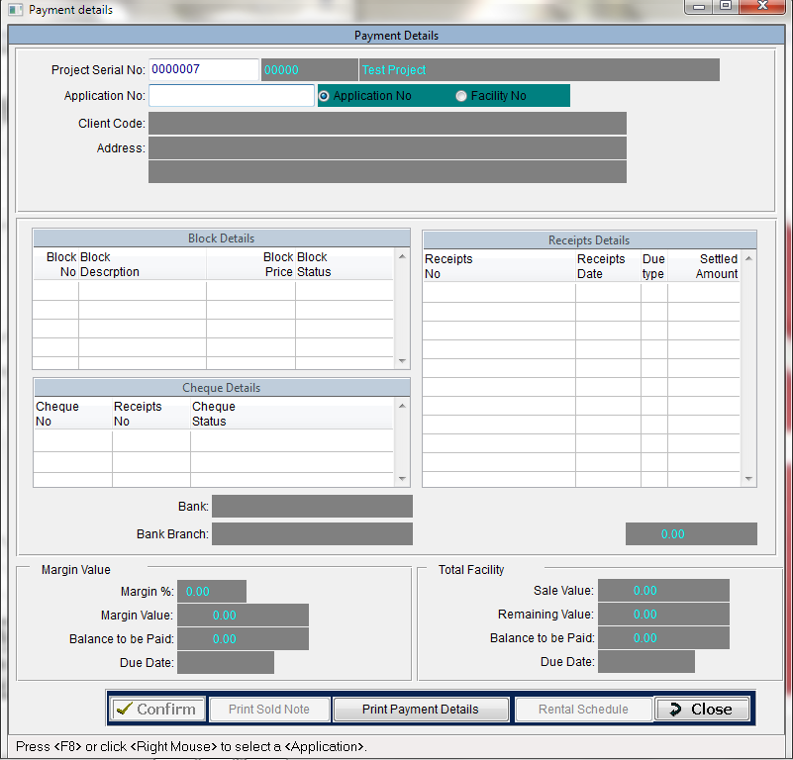

This screen allows users to view the payment details of the reserved block. Also user can print the payment detail report as well as the sole note report.

Sole note will be available once the customer pay 30% of the total agreed price.

Maintenance🡪 Direct Debit

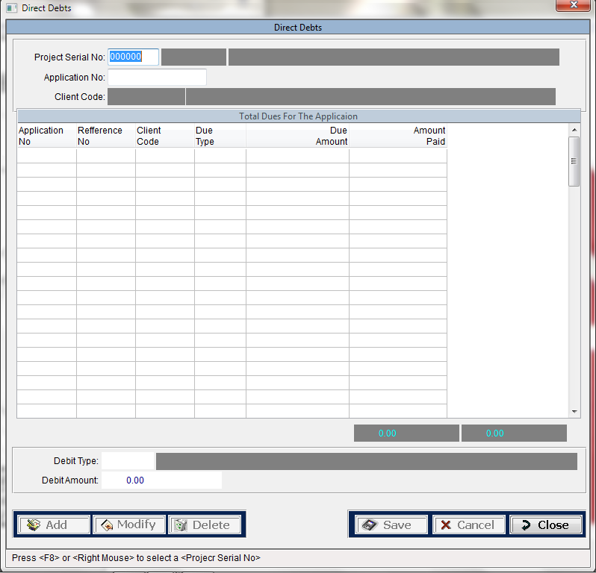

This screen allows users to debit other chargers to the customer.

**Filed List**

Debit Type

Debit amount

Maintenance🡪 Reminder Printing

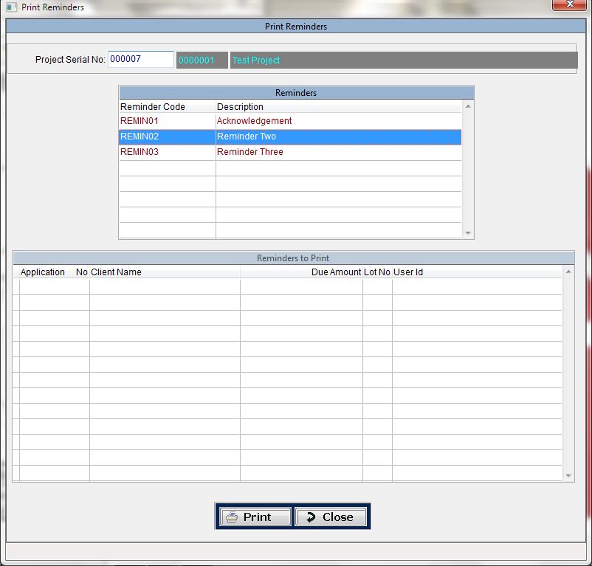

Reminders are generated during the day end process and generated reminders are kept in a pool. Any user can log in to the system retrieve the reminders from the pool and print.

Maintenance🡪 Reminder Re-Printing

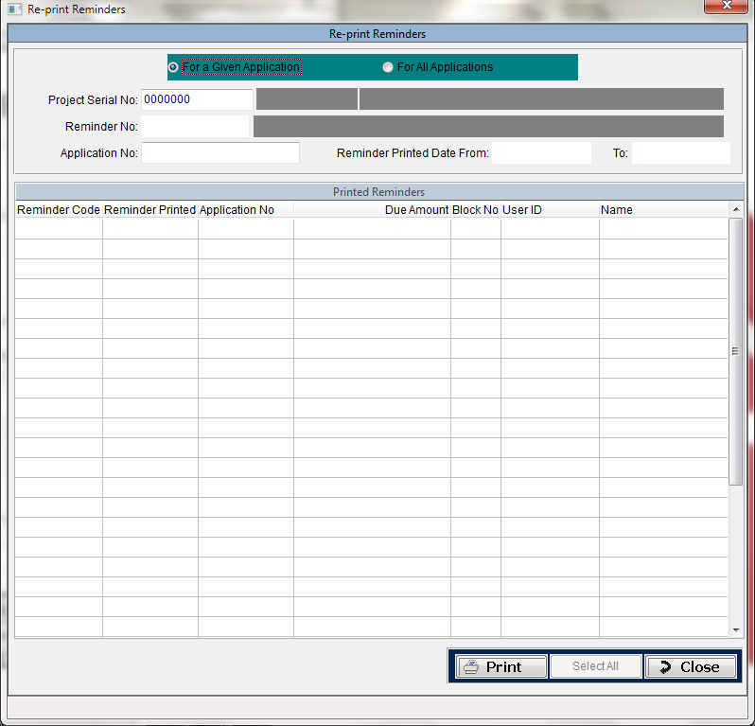

This screen allows users to re-print the reminder.

Maintenance🡪 Termination

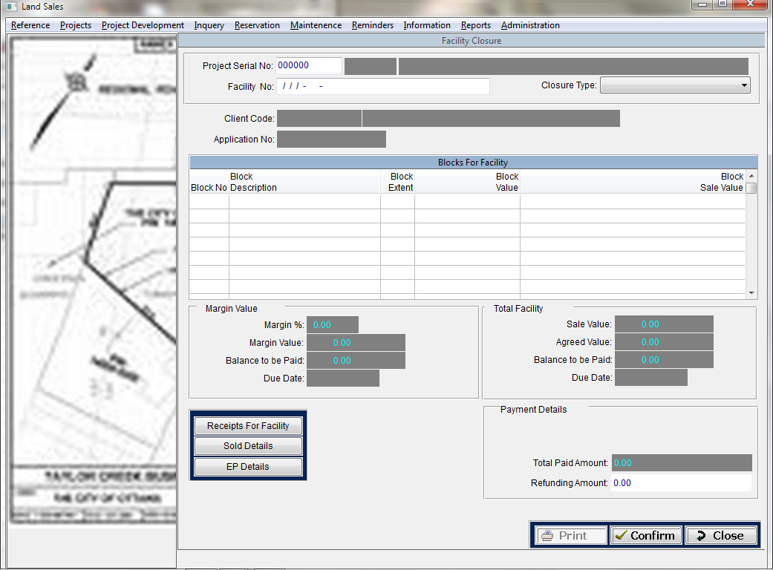

At any given stage customer can cancel the block reservation. Therefore company has to decide the payment refund for the customer.

**Filed List**

Refund amount.

Information🡪 Info Console

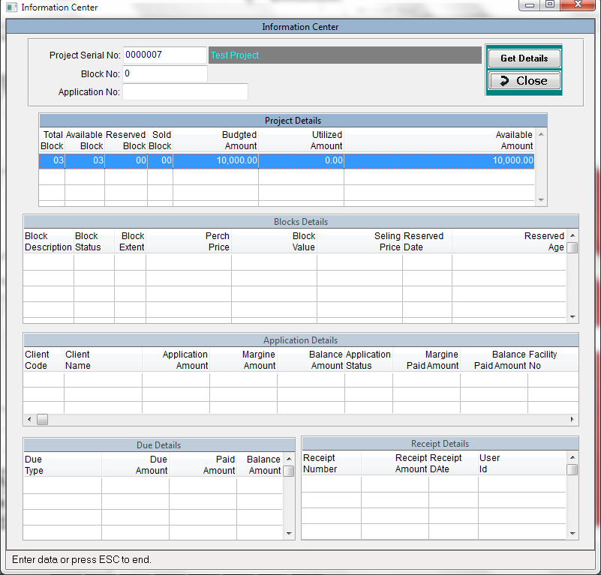

User can view the all information for the block.

Information🡪 Site Map

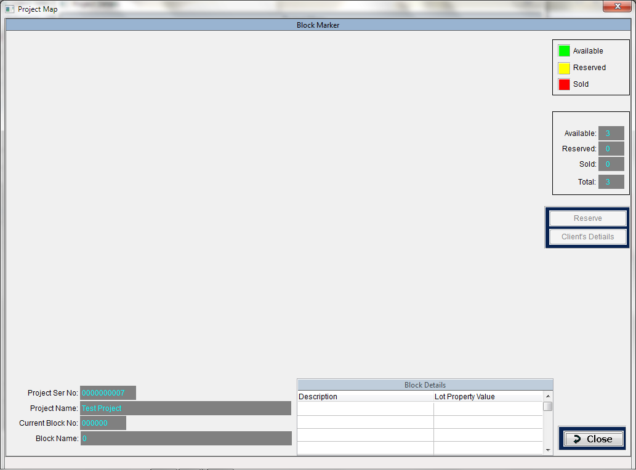

Information🡪 Actual Vs Budgeted

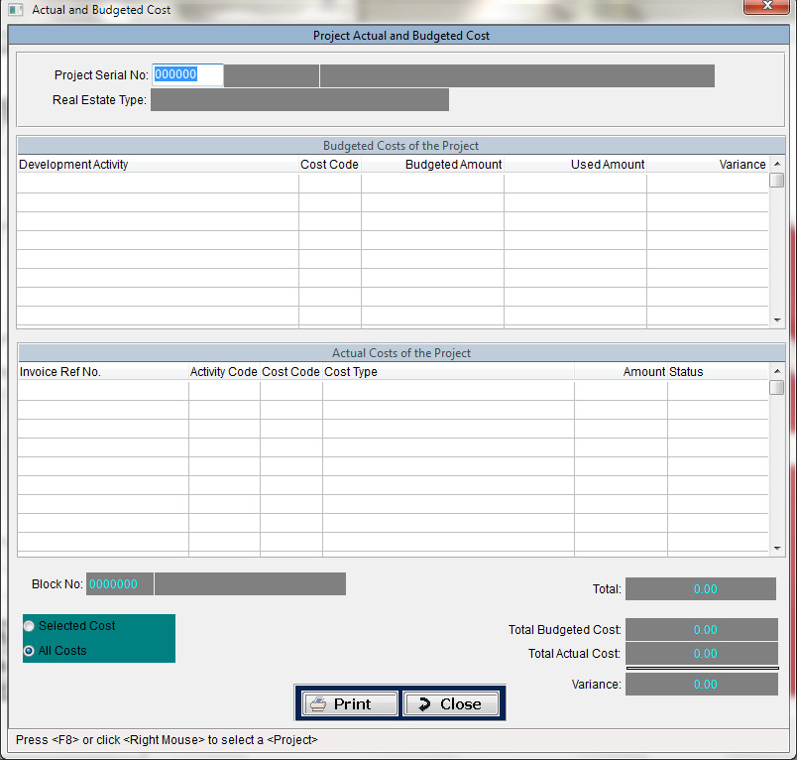

Information🡪 Age Analysis

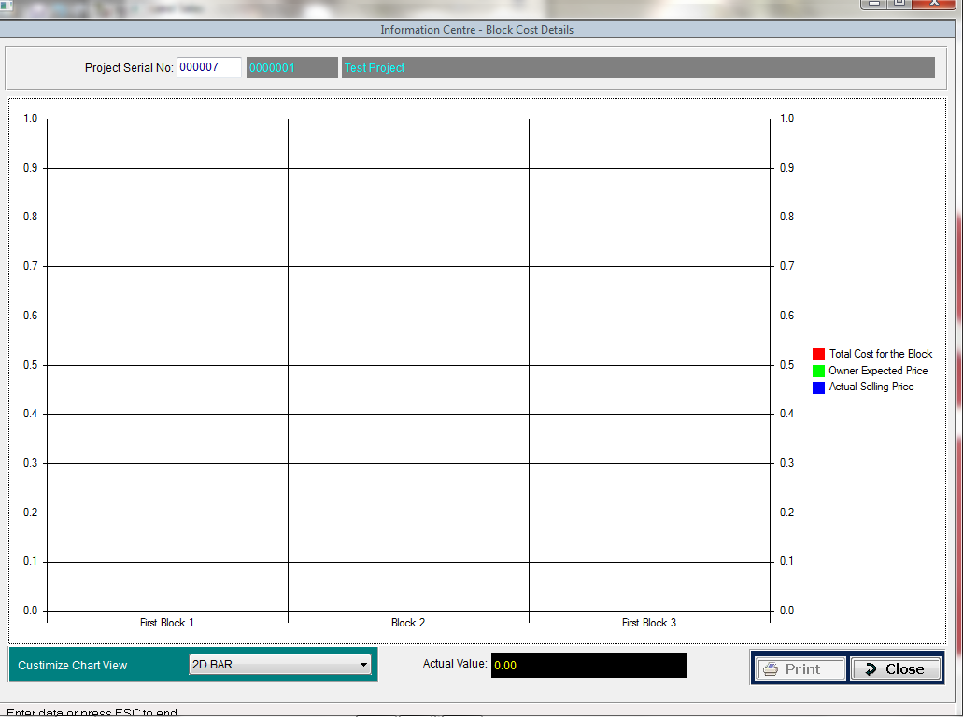

Inquiry🡪 Make Inquiry

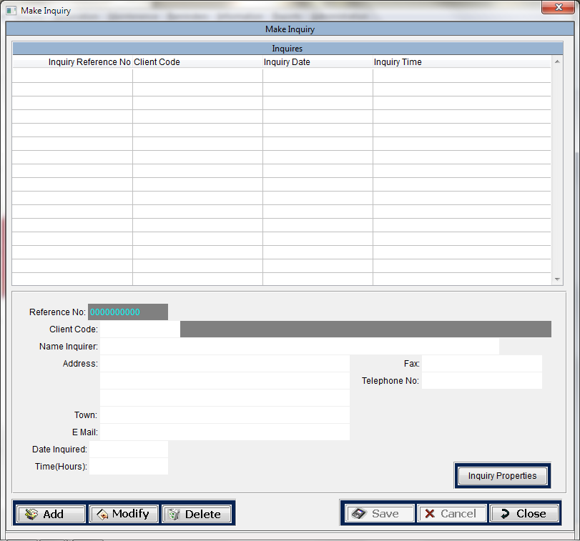

Inquiry🡪 Inquiry Properties

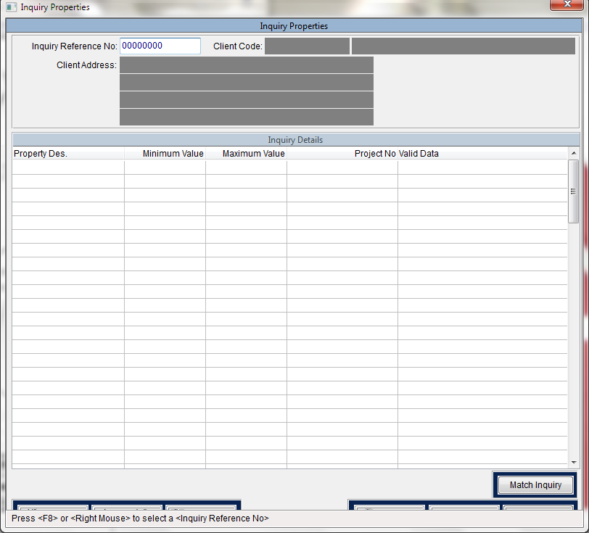

Inquiry🡪 Match Inquiry

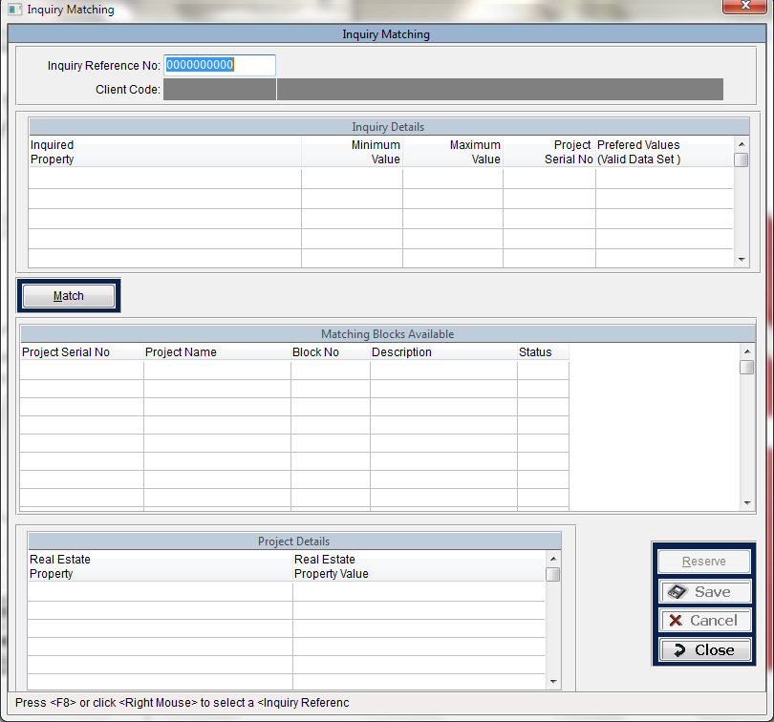

Reference🡪Activity

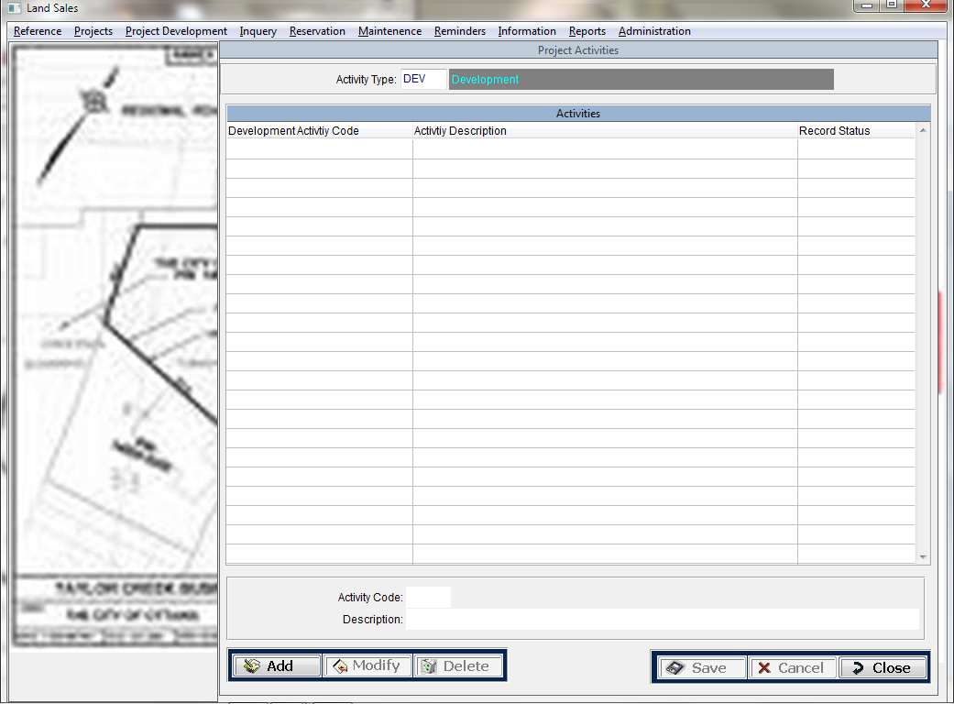

Reference🡪Activity Type

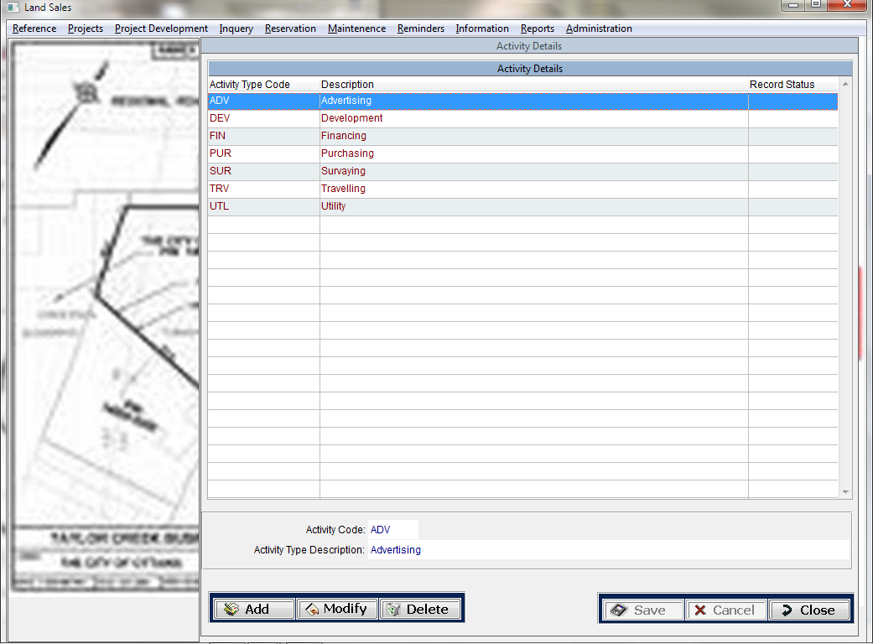

Reference🡪Area Type

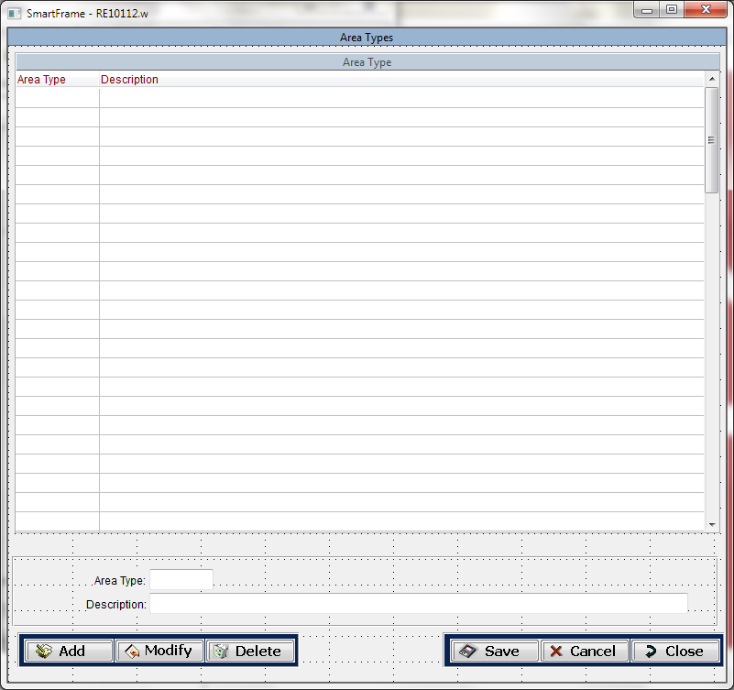

Reference🡪Cost Type

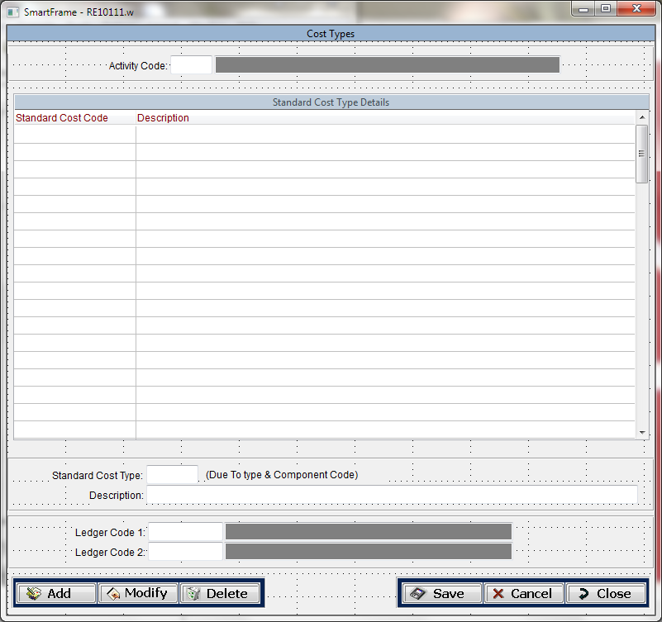

Reference🡪Income Type

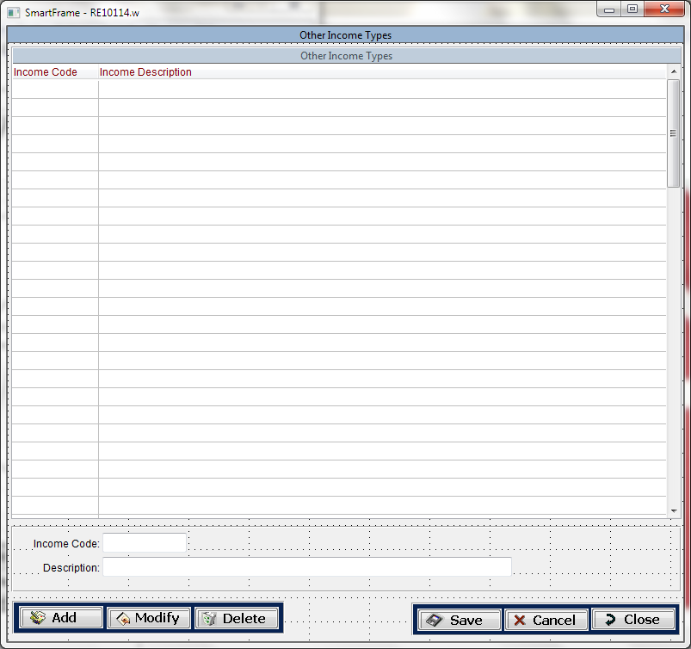

Reference🡪Parameters

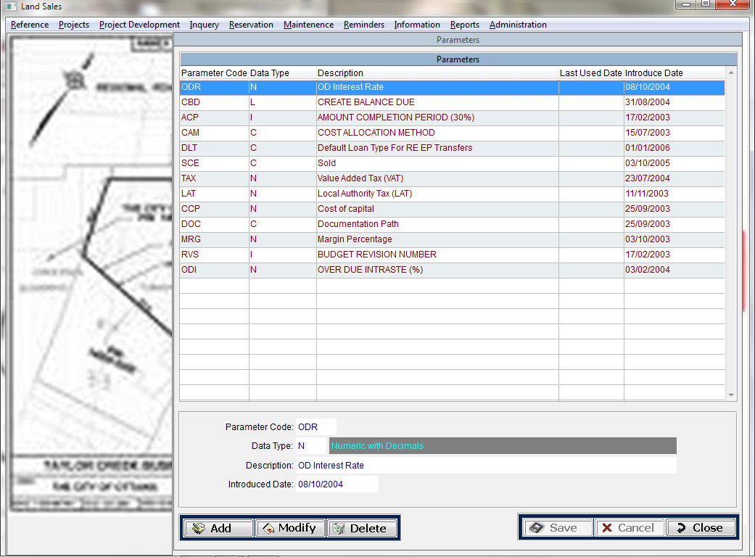

Reference🡪Parameter Values

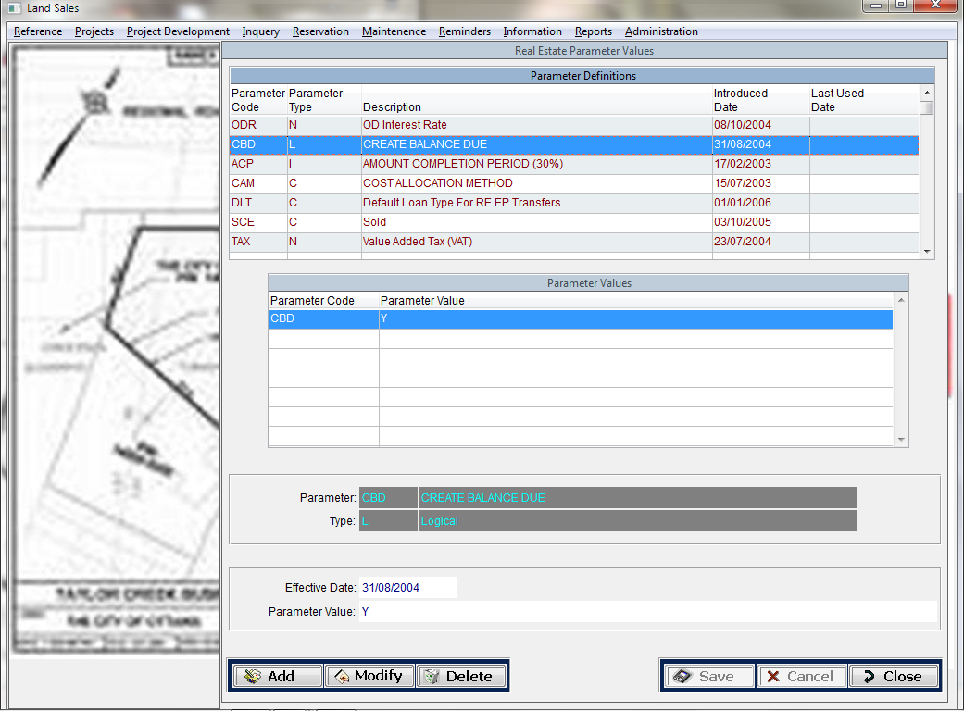

Reference🡪Real Estate Types

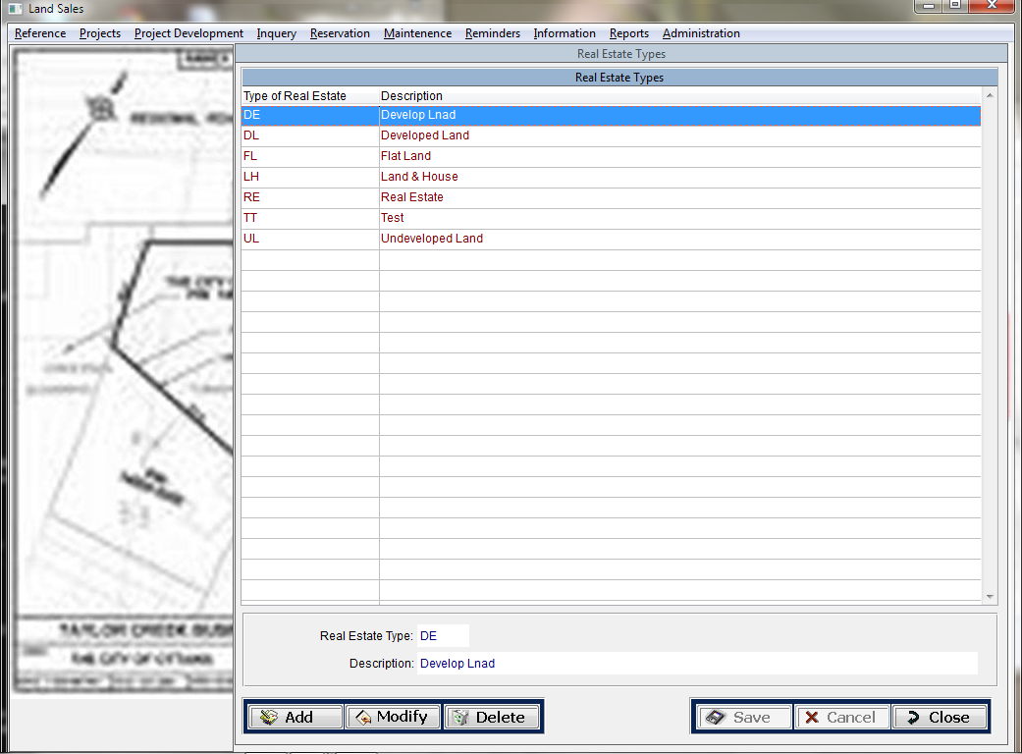

Reference🡪Reminder Parameters

